Finance Your Future – Instructor Portal

Creating an Instructor account in Finance Your Future allows you to create customized lessons for your students and track their progress.
To create a Finance Your Future Instructor account:
- Navigate to the Finance Your Future website: http://financeyourfuture.myfloridacfo.com/.

- At the bottom of the page under the “Get Started Now” button, click the link for “Educators click here for more information on using this in your classroom”.
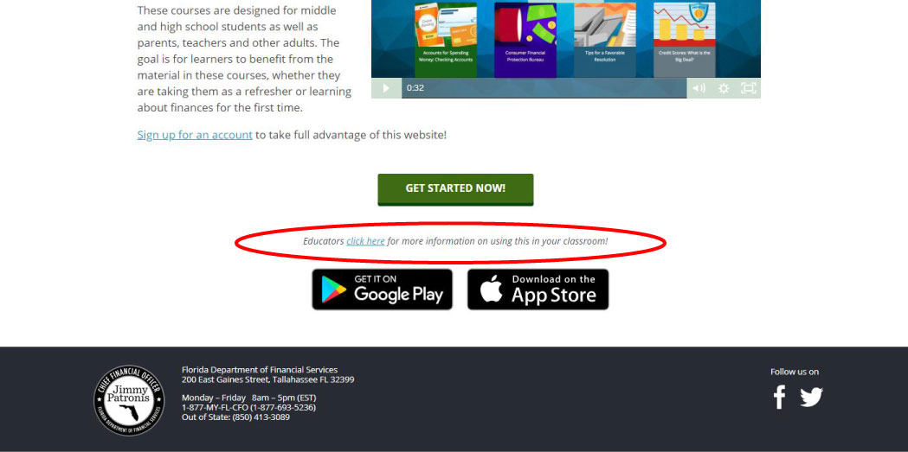
- The Information for Educators page will open displaying an overview of the Instructor Portal features. At the bottom of this page, click the “Register Now!” button.
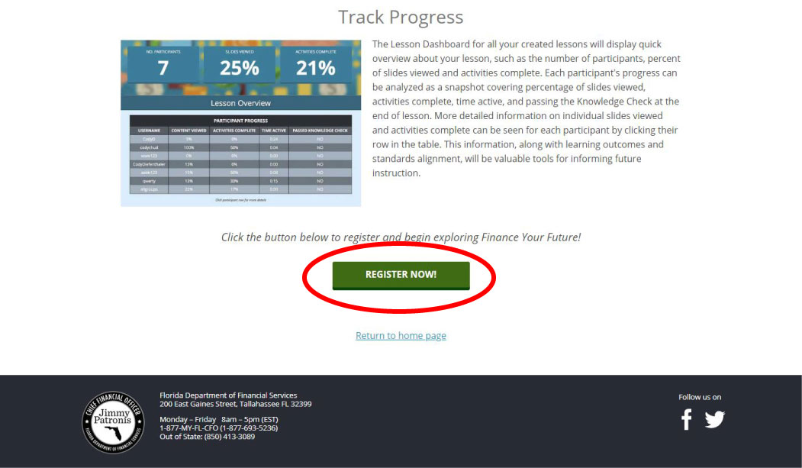
- Create a username and complete the fields with your personal information: First Name, Last Name, Password, Confirm Password, Email and Confirm Email.
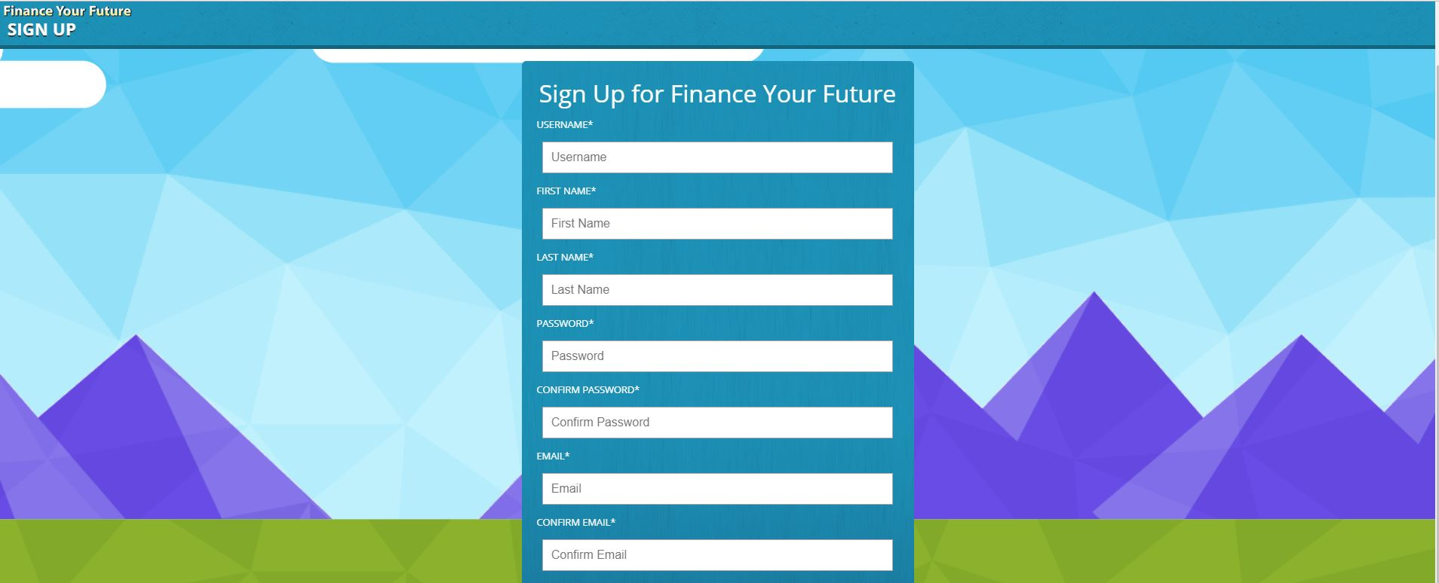
- Check the box “Yes” under “Are you an Instructor” to specify you are creating an instructor account.
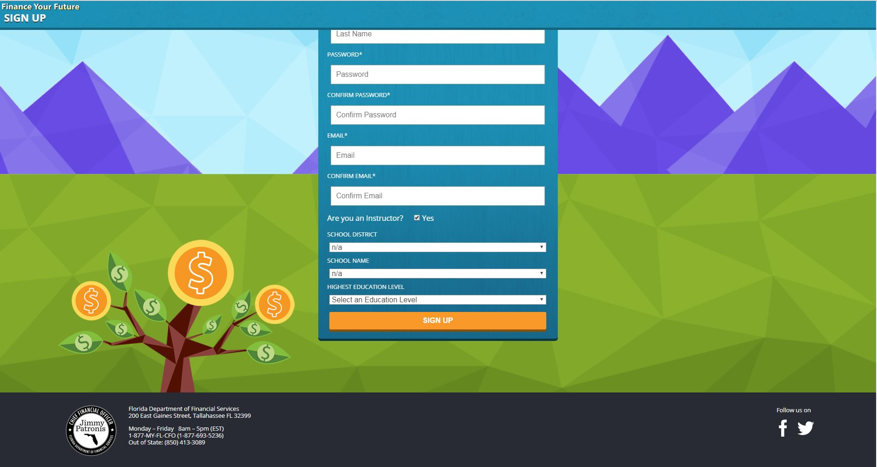
- If you are a teacher, choose your School District and School Name in the drop down menus for each field. If you are not an instructor, or your school is not listed, please choose “n/a” in the drop down menu for both School District and School Name.

- Select your education level for data collection purposes.

- Click the “Sign Up” button.

You have now successfully created a Finance Your Future Instructor account. The username and password created will allow you to login into your account.

To create a customized lesson:
- Login to your Instructor account.

- On the Lesson Dashboard under the Created Lessons section, click the “Create a Lesson” button.
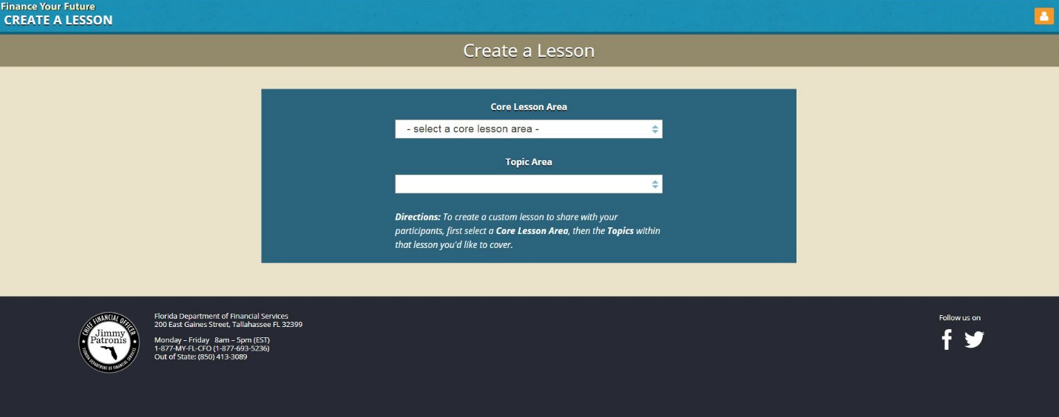
- Choose a Core Lesson Area in the drop down menu for your customized lesson. The Core Lesson Area choices are based on the eight core lesson modules in Finance Your Future: Budgeting & Saving, Credit Cards, Banking, Credit Report & Score, Debt, Frauds & Scams, Insurance & Benefits and Life Events.

- Next, choose a Topic Area for your customized lesson. You can choose all the topics available in the Core Lesson Area or you may choose only the topic you would like to cover.
When you choose a Topic Area, information about that topic will appear on the page. This information includes the Learning Outcomes, Slides that will be added to the lesson and the Florida Standards (learning objectives) that are met in this Topic Area.
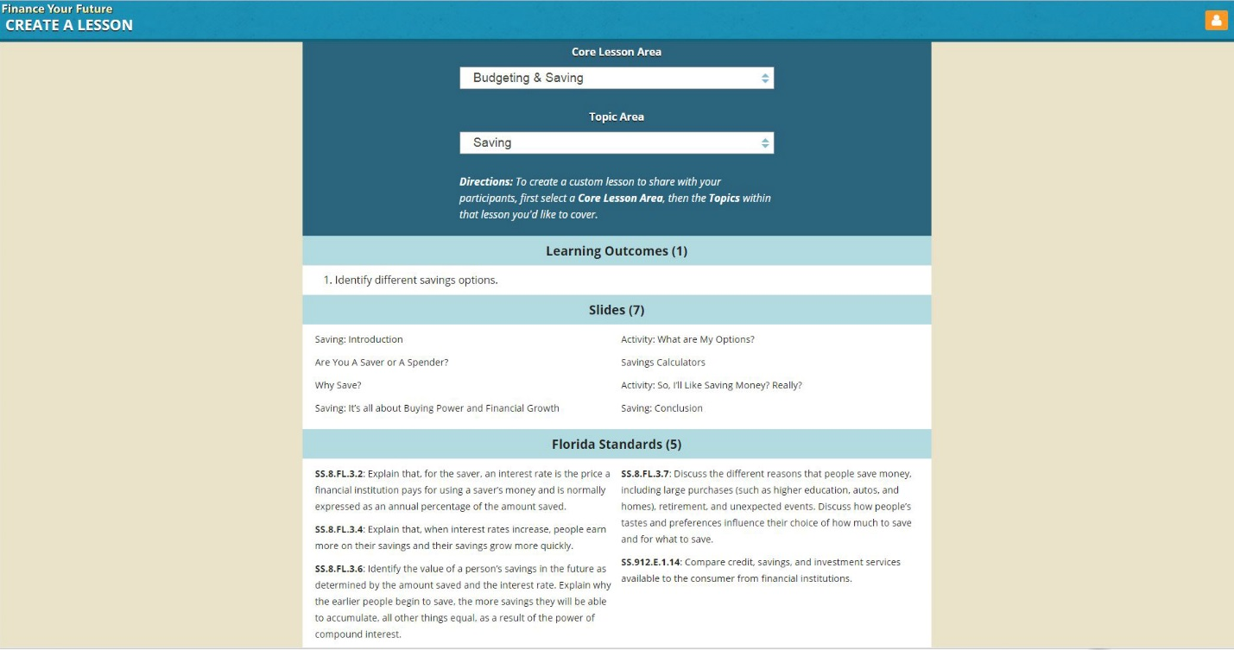
- Under this information, enter a custom title for your lesson in the Lesson Title field.

- In the Class Subject Area field, enter identifying course information for your lesson. This may be the name of the class this lesson is for (ex: “Social Studies – Period 2”), the general subject area (“Budgeting”) or anything information you choose to add.

- Under Participant Grade Level(s), use the drop down menu to choose which grade level will be using your customized lesson.
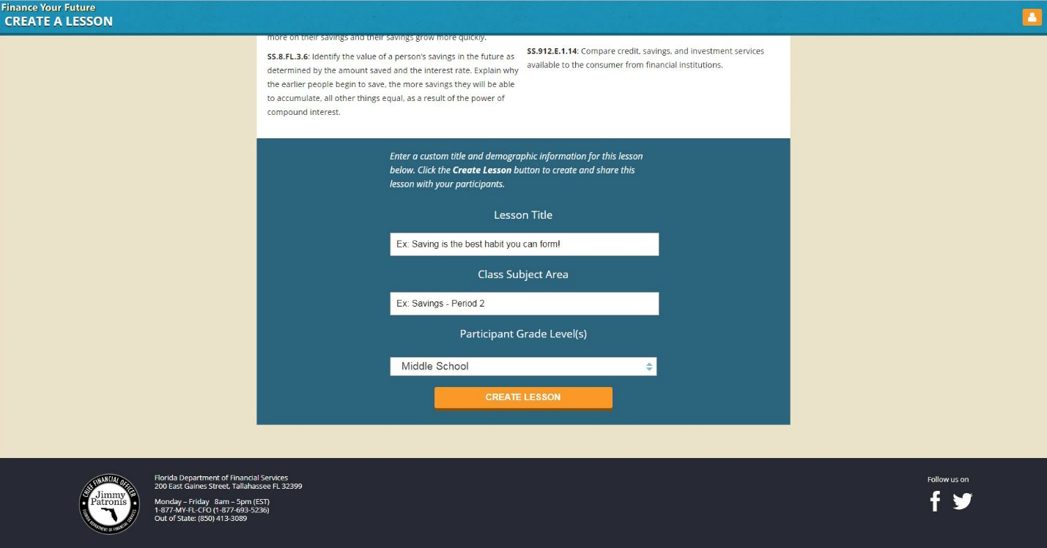
- Click the “Create Lesson” button to finalize the custom lesson.
Once your lesson is created, an invite code and link to the customized lesson will appear.

Sharing customized lessons with students:
Once you create a customized lesson, a confirmation page will appear with an Invite Code, Invite Link and button option to Email Lesson.
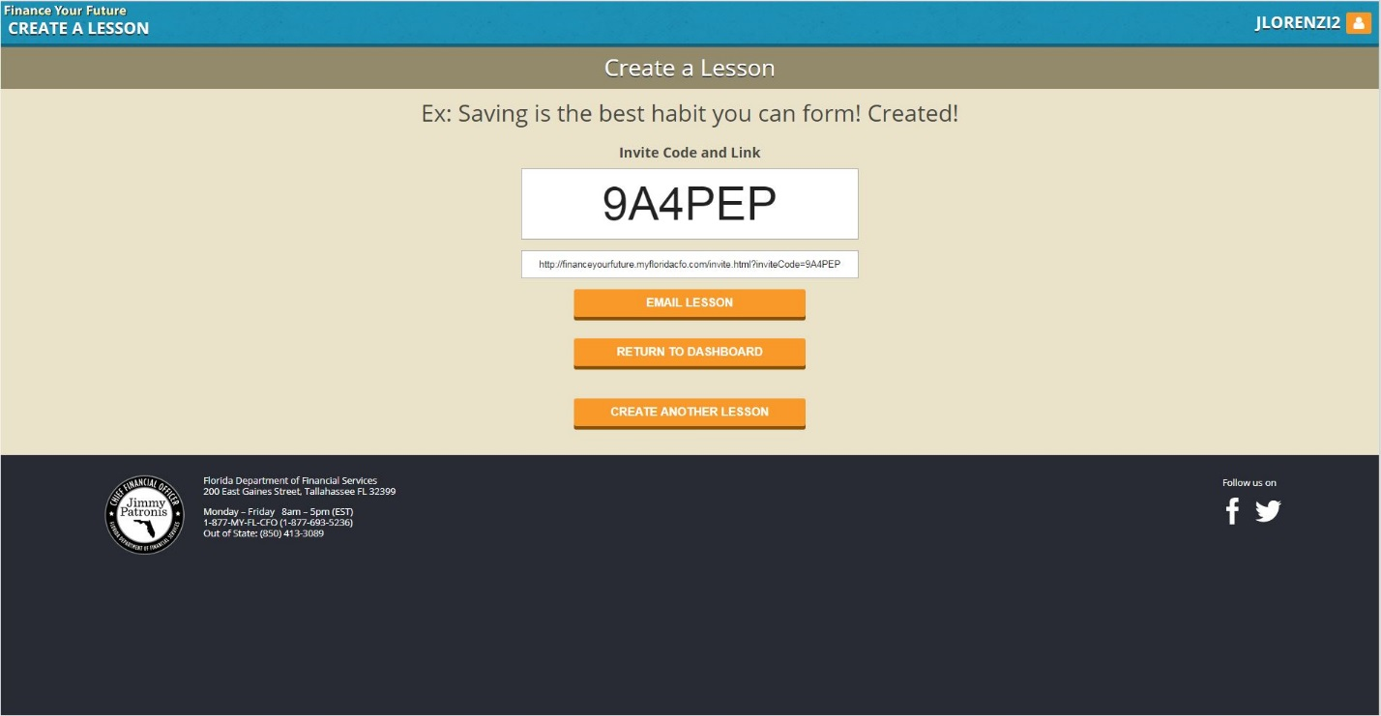

You can share the lesson with students using any of these methods:
- Write down the six character Invite Code and share it with your students. Each customized lesson has a unique invite code.

- Copy the Invite Link displayed in the field below the Invite Code on the confirmation page and share the link with your students. You can paste it into an email, onto an online post or any method you share information with students.

- Automatically email the Invite Code and Invite Link to your students by clicking on the “Email Lesson” button. This button will open the default mail application on your device and prepopulate the subject and body of your email.
  - Subject: “Invitation to join (custom title of your lesson)”
  - Body: Here's an invitation to join Ex: Saving is the best habit you can form! on Finance Your Future. Your invite code is 9A4PEP. You can join this lesson by accessing the following link: http://fyf-ip.fcim.org/invite.html?inviteCode=9A4PEP Enjoy!
All you will have to do is enter the student(s) email address(es) in the address field and click send.
